AgingME GWEP Steering Committee
Year Two Collaboration Assessment
July 2021

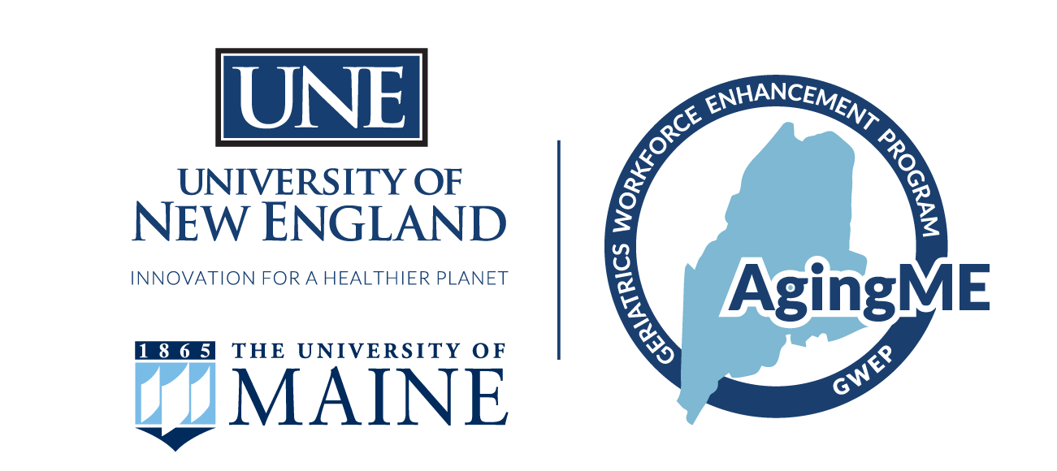

Section I. Overview

The purpose of AgingME Geriatrics Workforce Enhancement Program (GWEP) is to improve the health and well-being of Maine’s older adults through training enhancements at the primary care practice level and at multiple points along the education trajectory of health professionals, older adults and care partners. This will be done by improving the alignment of new and existing primary care and community-based efforts in geriatrics and creating synergies for the well-being of older Mainers. According to its charter, The AgingME Steering Committee was formed in October 2019 and is tasked with providing general program oversight for the AgingME GWEP. This group meets quarterly to review project progress, share updates, and other events and information of interest.

The following report summarizes results from a survey that was administered to the Steering Committee at the conclusion of the second year of the AgingME GWEP grant (June 2021) to identify collaboration strengths and areas for improvement in both the committee’s work and the work of the broader GWEP efforts. The committee had met five times prior to the administration of this survey. While there are core members who have remained with the group over the course of the two year period, some members have rotated out or onto the committee based on their current role with the project.

Wilder Collaborative Factors Survey
This anonymous survey was distributed online via the Qualtrics survey platform to the 15 Steering Committee members, inclusive of UNE project staff. A total of 9 responses were obtained for a 60% response rate. The survey consisted of two components. The first was the Wilder Collaborative Factors Inventory, an established measure consisting of 44 questions that represent 22 different research-based factors that underpin successful collaboration. The survey version used was the 2018 3rd edition of the CFI. Factors contained within the survey include concepts like shared vision, unique purpose, collaboration history among members, skilled leadership, political and social climate, and mutual respect (see appendix for full factor list). The second section of the survey was comprised of six open response questions designed to measure process-level challenges and opportunities for improvement.

An analysis by factor is provided in this report. A description of each factor and the questions contained in each factor and a comparison with last year’s results is included in the report appendix in addition to a question-by-question analysis.
Section II. Wilder Factors by Average Score

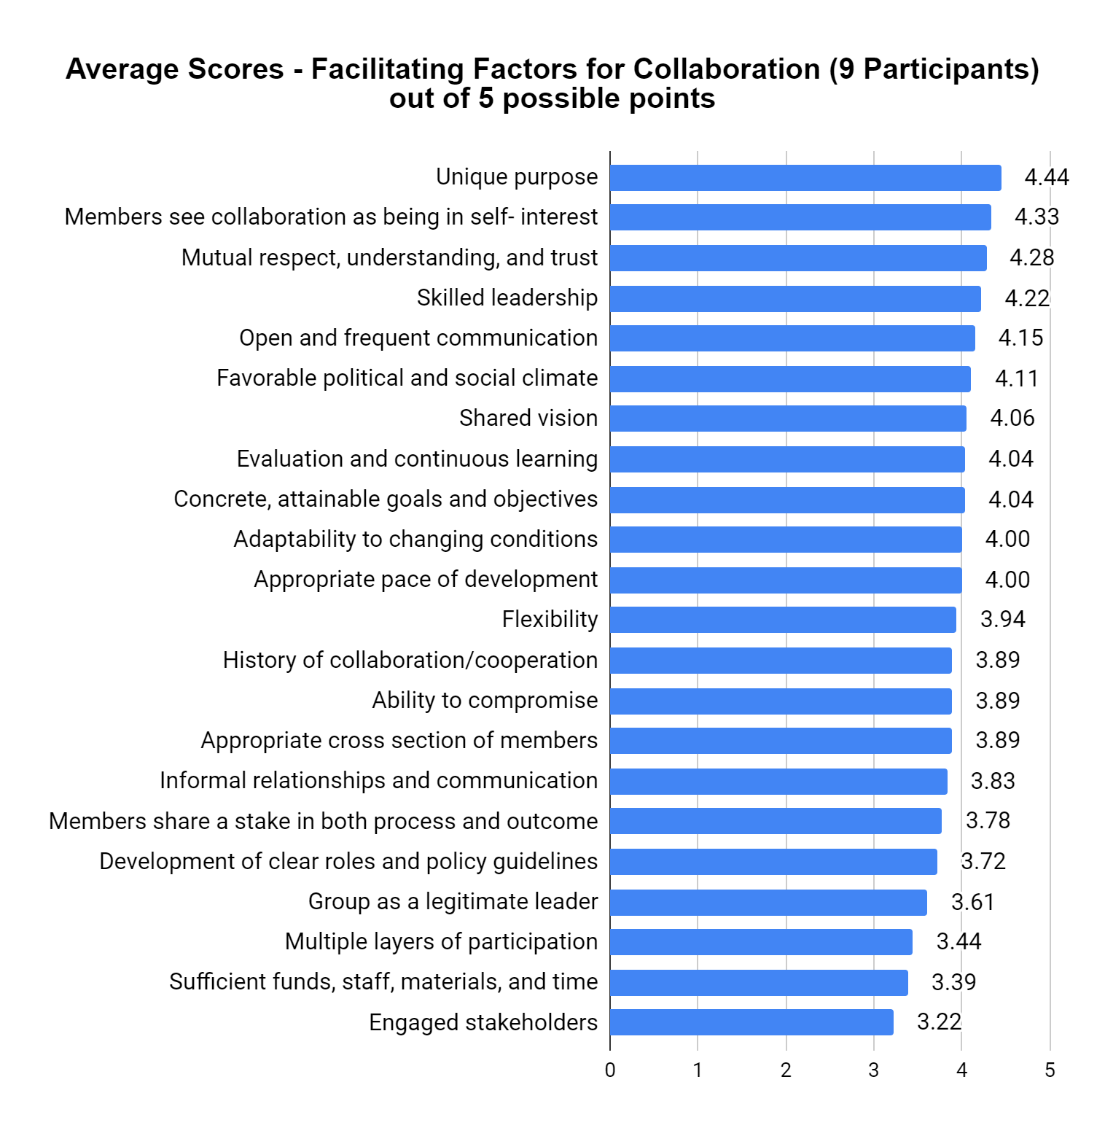

Section III. Write-In Responses

What do you see as the most valuable role that the AgingME project could play in addressing age-friendly healthcare training needs across the state? (N=7)

Responses to this question highlight the provision of funding, support, and sharing of interdisciplinary knowledge for improving training and education opportunities. Broadly, promoting awareness of education and support and improving communication between agencies was also mentioned.

Responses:

- Persistent work toward [*unintelligible response*] together
- Ongoing funding and support to provide educational opportunities
- Sharing interdisciplinary information to use in training more often
- Supporting health professions programs to enhance curriculum and collaborate with agencies that provide care to older adults
- Educating others in health and service sectors and older adults
- Helping providers know what outside support is available and getting the support agencies to communicate and coordinate care and support
- Continuing to emphasize the importance and continue to education broadly

What changes would you recommend in the collaboration process to make the group as effective as possible? (N=6)

Responses to this question highlighted that COVID continues to impact functioning and that the budget is perceived as inflexible. Two responses were efficiency related, mentioning shortening calls and improving procedures through personnel changes.

Responses:

- Reducing the impact of COVID on our ability to pursue work together
- None
- Keep calls shorter
- The budget process feels rigid
- It will be nice when this pandemic ends to have an occasional in-person meeting
- We need to get everything hard wired so that it will continue even if the people doing the work change

Do you see any barriers in making those changes? (N=7)
Respondents highlighted competing priorities, including COVID vaccination efforts, and a lack of collaboration on budgetary decisions as key barriers. Personnel-related barriers included a lack of time to implement changes, and staff turnover.

Responses:

- Finishing vaccination efforts with those hesitant to engage
- N/A or “no” (4 responses)
- The budget decisions are not collaborative in nature - an advisory group on budget could offer broader opportunities
- Time, turnover in the people, competing priorities

Do you have any suggestions for the ways that we can better involve community members in this project? (N=6)

Responses to this question included asking audiences at the conclusion of classes and presentations, improving media coverage of activities, and taking advantage of existing relationships. COVID was again mentioned as a drain on the ability to involve community members with efforts going towards improving vaccination rates.

Responses:

- The pandemic has made involvement difficult for many, and diverted the efforts of partners to more urgent vaccination efforts.
- Ask at the end of each class, presentation, etc.
- More press coverage of the project's activities
- Not at this time/No (two responses)
- Not really - taking advantage of relationships

How might we increase participation of Steering Committee members (including yourself)? (N=6)

Participation improvements were suggested by having shorter and smaller group meetings, holding meetings earlier in the day, and through providing a brief weekly progress update on each grant team. One comment specifically highlighted that having clear expectations of members, specific tasks and deadlines, and improved communication and expectations about agenda items could improve participation of members.

Responses:

- See above - efforts have been diverted to more urgent needs
- Smaller, shorter group meetings. Earlier in the day. I’m exhausted by 5.
- I'm not sure. I think that I am contributing a fair amount.
- Brief weekly updates about the progress of each grant team
- Not sure, other than the meetings
- Specific assignments/deadlines
- Identifying outright expectations and expertise of various steering committee members (do we have any gaps)
- Earlier agenda with clear guidance on who needs to say what

Are there other ways you would like to participate in the work of the Steering Committee? (N=5)

Specific participation suggestions included a plan for future funding and an advisory committee on budget allocations. One respondent suggested that a work group be initiated if a need for specific work outside of the current steering committee’s commitments is identified.

Responses:

- N/A
- Perhaps to start working on a plan for securing funding once this project is over
- Would like to suggest the advisory committee on budget allocations
- Already balancing my other duties
- Let's just make sure that the steering committee remains that - if there is more specific work, a work group may be needed for specific areas/gaps

Section IV. Summary and Implications

Survey findings underscore early strengths of the Steering Committee group within the following factors:
  - Unique purpose (Factor 19)
  - Members see collaboration as being in self-interest (Factor 6)
  - Mutual respect, understanding, and trust (Factor 4)
  - Skilled leadership (Factor 21)

These findings indicate that the AgingME GWEP serves a unique purpose in the state and one that cannot be fulfilled by one organization alone. The members view AgingME GWEP as being of value and a benefit to their own organization. There is a foundation of trust and respect among members. Those in leadership roles are viewed as having good skills for this collaboration between people and organizations.

At the same time, findings also indicate growth potential in the following factors based on the factor average score:
- Engaged stakeholders (Factor 22)
- Sufficient funds, staff, materials, and time (Factor 20)

Ratings in these areas indicate the need to focus on identifying stakeholders and engaging them more effectively. Internally, the collaboration has a need to improve funding allocations and people assigned to projects, both in the long and short term to improve project successes.

It is also noteworthy that only one respondent indicated strong disagreement on the 44 Likert scale questions, and only to one question (Question: Our collaborative group has adequate funds to do what it wants to accomplish).

Survey findings demonstrate that participants value the collaboration due to its ability to better educate and prepare providers working with older adults in order to effectively serve them. Challenges were noted with regard to timing and frequency and content covered during meetings. Barriers to addressing challenges include time and scheduling conflicts as well as Covid-19 related challenges.

Suggestions offered for further engaging community members included garnering more press coverage for project activities and gathering feedback from community members about how they would like to be involved in project activities.

Respondents also offered suggestions for increasing member participation in the group. These included shorter meetings, meeting earlier in the day, more regular brief updates from project teams, giving members specific assignments and deadlines, clarifying agenda items for meetings, and making explicit the expectations of steering committee members.

Appendix: Factor Descriptions, Averages, and Question-Level Analysis

Factor | Statement | Factor Score  (out of 5)
 |  | 2020 | 2021
1. History of collaboration or cooperation in the community | 1. Agencies in our community have a history of working together.  2. Trying to solve problems through collaboration has been common in this community. It has been done a lot before. | 4.27 | 3.89
2. Collaborative group seen as a legitimate leader in the community | 3. Leaders in this community who are not part of our collaborative group seem hopeful about what we can accomplish.  4. Others (in this community) who are not a part of this collaboration would generally agree that the organizations involved in this collaborative project are the “right” organizations to make this work. | 3.64 | 3.61
3. Favorable political and social climate | 5. The political and social climate seems to be “right” for starting a collaborative project like this one.  6. The time is right for this collaborative project. | 4.27 | 4.11
4. Mutual respect, understanding, and trust | 7. People involved in our collaboration trust one another.  8. I have a lot of respect for the other people involved in this collaboration. | 4.31 | 4.28
5. Appropriate cross section of members | 9. The people involved in our collaboration represent a cross section of those who have a stake in what we are trying to accomplish.  10. All the organizations that we need to be members of this collaborative group have become members of the group. | 3.95 | 3.89
6. Members see collaboration as being in their self- interest | 11. My organization will benefit from being involved in this collaboration. | 4.00 | 4.33
7. Ability to compromise | 12. People involved in our collaboration are willing to compromise on important aspects of our project. | 3.45 | 3.89
8. Members share a stake in both process and outcome | 13. The organizations that belong to our collaborative group invest the right amount of time in our collaborative efforts.  14. Everyone who is a member of our collaborative group wants this project to succeed.  15. The level of commitment among the collaboration participants is high. | 4.03 | 3.78
9. Multiple layers of participation | 16. When the collaborative group makes major decisions, there is always enough time for members to take information back to their organizations to confer with colleagues about what the decision should be.  17. Each of the people who participate in decisions in this collaborative group can speak for the entire organization they represent, not just a part. | 3.45 | 3.44
10. Flexibility | 18. There is a lot of flexibility when decisions are made; people are open to discussing different options.  19. People in this collaborative group are open to different approaches to how we can do our work. They are willing to consider different ways of working. | 3.95 | 3.94
11. Development of clear roles and policy guidelines | 20. People in this collaborative group have a clear sense of their roles and responsibilities.  21. There is a clear process for making decisions among the partners in this collaboration. | 3.64 | 3.72
12. Adaptability to changing conditions | 22. This collaboration is able to adapt to changing conditions, such as fewer funds than expected, changing political climate, or change in leadership.  23. This group has the ability to survive even if it had to make major changes in its plans or add some new members in order to reach its goals. | 3.86 | 4.00
13. Appropriate pace of development | 24. This collaborative group has been careful to take on the right amount of work at the right pace.  25. This group is currently able to keep up with the work necessary to coordinate all the people, organizations, and activities related to this collaborative project. | 3.63 | 4.00
14. Evaluation and continuous learning | 26. A system exists to monitor and report the activities and/or services of our collaboration.  27. We measure and report the outcomes of our collaboration.  28. Information about our activities, services, and outcomes is used by members of the collaborative group to improve our joint work. | 4.00 | 4.04
15. Open and frequent communication | 29. People in this collaboration communicate openly with one another.  30. I am informed as often as I should be about what is going on in the collaboration.  31. The people who lead this collaborative group communicate well with the members. | 3.91 | 4.15
16. Established informal relationships and communication links | 32. Communication among the people in this collaborative group happens both at formal meetings and in informal ways.  33. I personally have informal conversations about the project with others who are involved in this collaborative group. | 3.95 | 3.83
17. Concrete, attainable goals and objectives | 34. I have a clear understanding of what our collaboration is trying to accomplish.  35. People in our collaborative group know and understand our goals.  36. People in our collaborative group have established reasonable goals. | 3.88 | 4.04
18. Shared vision | 37. The people in this collaborative group are dedicated to the idea that we can make this project work.  38. My ideas about what we want to accomplish with this collaboration seem to be the same as the ideas of others. | 4.00 | 4.06
19. Unique purpose | 39. What we are trying to accomplish with our collaborative project would be difficult for any single organization to accomplish by itself.  40. No other organization in the community is trying to do exactly what we are trying to do. | 4.41 | 4.44
20. Sufficient funds, staff, materials, and time | 41. Our collaborative group has adequate funds to do what it wants to accomplish.  42. Our collaborative group has adequate “people power” to do what it wants to accomplish. | 3.73 | 3.39
21. Skilled leadership | 43. The people in leadership positions for this collaboration have good skills for working with other people and organizations. | 4.09 | 4.22
22. Engaged stakeholders | 44. Our collaborative group engages other stakeholders, outside of the group, as much as we should. | 4.09 | 3.22

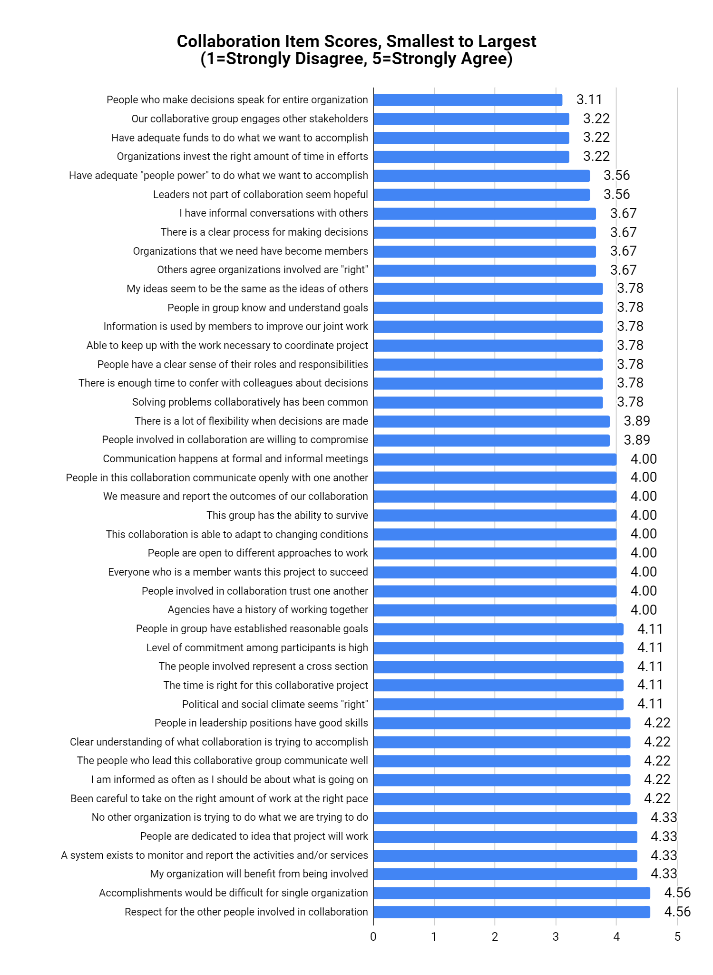

Mattessich, P., & Johnson, K. M. (2018). Collaboration what makes it work. New York, NY: Turner Publishing
Wilder Research. (2020). Wilder Collaboration Factors Inventory. https://wilderresearch.org/tools/cfi-2018/start

